Chemistry: 9. The Periodic Table
Please remember to photocopy 4 pages onto one sheet by going A3→A4 and using back to back on the photocopier

Syllabus
OC48 Understand that alkali metals are in Group I of the Periodic Table

OC50 Understand that Group II elements are the alkaline earth metals

OC4 Examine a variety of substances and classify these as metals or non-metals

OC5 List the physical properties (state and colour only) of two examples of metallic and two examples of non- metallic elements

OC8 Recall the symbols of the metallic elements Cu, Zn, Al, Fe, Ag, and Au

OC9 Recall the symbols of the non-metallic elements C, O, S, H and N

Student Notes
The Periodic Table

Remember from the last chapter on The Atom that the first10 elements, arranged in order of increasing atomic number (the number of protons in the atom), are as follows:
Atomic number | 1 | 2 | 3 | 4 | 5 | 6 | 7 | 8 | 9 | 10
Element | Hydrogen | Helium | Lithium | Beryllium | Boron | Carbon | Nitrogen | Oxygen | Fluorine | Neon
Symbol | H | He | Li | Be | B | C | N | O | F | Ne

The next 10 elements:
Atomic number | 11 | 12 | 13 | 14 | 15 | 16 | 17 | 18 | 19 | 20
Element | Sodium | Magnesium | Aluminium | Silicon | Phosphorus | Sulphur | Chlorine | Argon | Potassium | Calcium
Symbol | Na | Mg | Al | Si | P | S | Cl | Ar | K | Ca

A mystery solved!
The list above is of the first 20 elements – but there are over 100 different types of element and if we arranged them all just in order of increasing atomic number we would end up with one very long row.
There must be a better way!

Over 100 years ago, scientists noticed that some of the elements were similar to each other, for example some groups of elements were very reactive while others were very un-reactive; some were solid at room temperature while others were always a gas at room temperature.

Could they use this to help them re-arrange the elements to devise a table that would help them see at a glance which elements go together?

There was one other piece of information which was going to prove vital to solving the puzzle.
In the last chapter (The Atom) you were asked to draw all 20 elements and I asked you if you noticed any way to group some of the different elements together?

Well there is, and it is as follows:

Step One.
- Group all the atoms which have just one electron in their outer shell together in one column.
- Group all the atoms which have two electrons in their outer shell together in another column.
- Do this for all the atoms.
- We’ll cause these columns ‘Groups’.

Step Two:
- Keep all the atoms which have just one shell together in one row.
- Keep all the elements which have two shells together in a second row.
- Do this for all the atoms.
- We call these rows ‘Rows’ (‘cause scientists have wonderful imaginations).

What they came up with is now called The Periodic Table of elements.

The Periodic Table is an arrangement of elements in order of increasing atomic number

Each column is known as a group and has similar properties

All the atoms in the first column have one electron in their outer shell; this group is called Group 1.
All atoms in the second column have two electrons in their outer shell; this group is called Group 2.
All atoms in the last column have a full outer shell; this group is called Group 8 or Group 0.

All the elements in the first row have just one shell.
All the elements in the second row have two shells.
All the elements in the third row have three shells.

- The metals in Group One are given a specific name; they are known as the alkali metals.

- The metals in Group Two are also given a specific name; they are known as the alkaline earth metals.

We will look more closely at these groups in a later chapter (entitled The alkali and alkaline earth metals).

Metals and non-metals
Another use of the periodic table is to allow us to group metals and non-metals together.

The metals are on the left-hand side of the table and the non-metals are on the right-hand side.
Some elements have characteristics of both metals and non-metals and these are known as metalloids.
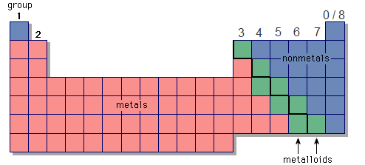

Properties of metals

- They conduct electricity
- They conduct heat
Demonstration: Metals conduct electricity
- Put the metal between the points X and Y in the circuit.
- Note that the bulb lights when the switch is turned on.

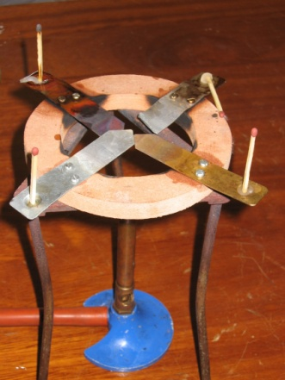

Demonstration: Metals conduct heat
- Arrange strips of various metals as shown, with a heat source in the centre and solid wax at the ends.
- Note the wax melts (and the matches fall) after a short time showing that the heat was conducted along the metal.

Non-metallic elements
Non-metallic elements tend to be poor heat and electrical conductors.
They are found on the right hand side of the periodic table and tend to be gases at room temperature

Examples of non-metallic elements
- Chlorine (Cl) is a yellow gas
- Oxygen (O) is a colourless gas
- Sulphur (S) is a yellow powder

Experiment: Examine a variety of substances and classify these as metals or non-metals
Method:
Check to see whether the substances conduct electricity and heat as shown above.

Symbols for some metallic and non-metallic elements

Metals |  |  | Non-metals
Metal | Symbol |  | Non-metal | Symbol
Copper | Cu |  | Carbon | C
Zinc | Zn |  | Oxygen | O
Aluminium | Al |  | Sulphur | S
Iron | Fe |  | Hydrogen | H
Silver | Ag |  | Nitrogen | N
Gold | Au

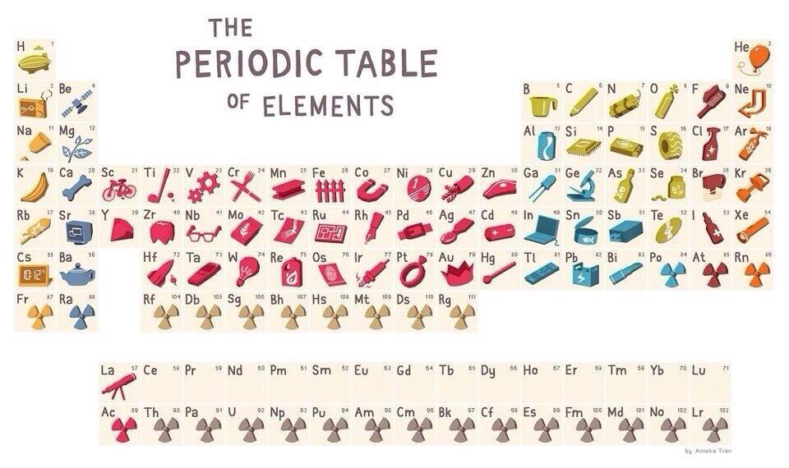

The Good Stuff
Where did it all come from?
In the universe 98 % is hydrogen and helium – everything else was made from exploding stars
Every breath you take contains atoms forged in the blistering furnaces deep inside stars.
Every flower you pick contains atoms blasted into space by stellar explosions that blazed brighter than a billion suns.
Every book you read contains atoms blown across unimaginable gulfs of space and time by the wind between the stars.

What are minerals?
The word ‘minerals’ is short for ‘mineral elements’.
These are elements in the periodic table. Iron and calcium are examples of mineral elements.

Scientists discover new element

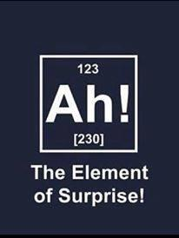

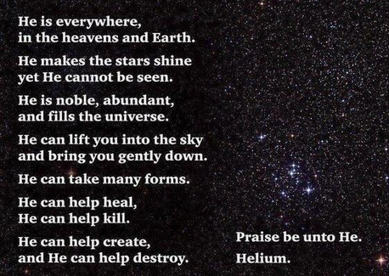
Exam Questions
Atoms
Elements
Compounds
Periodic table
- [2007 OL]
Complete the following sentence below inserting the correct words from the list on the right.
All the known _________________ are listed in the ____________________________.

- [2007]
Give two properties of alkali metals.

- [2008]
The diagram shows the first twenty elements in their positions in the periodic table. The number given with each element is the atomic number of that element.

- By what name are group two metals known?
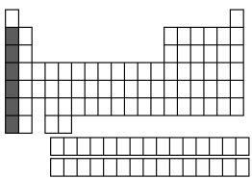
- Why are the noble gases, group 8/0, very chemically unreactive?

- [2011]
The diagram is an outline periodic table.
One area, a group of elements, is shaded.

Name this group of elements and give one chemical property that they have in common.

- [2006][2012 OL]

- Show, clearly using shading and labelling, the location of the alkaline earth metals on the blank periodic table given.
- Name an alkaline earth metal.

- [2008 OL]
Solids can be metals or non-metals.
Identify two non-metals from the elements whose symbols are shown on the right.

- [2012][2012 OL]
Name two non-metallic elements.
Exam Solutions
- Elements
Periodic table
- Soft (can be cut with a knife), low density(float on water), shiny (lustrous) when cut, tarnish(form oxide) (reacts) with air/ burn in air, coloured flames, react with water, hydrogen produced with water, hydroxides formed with water/, silver’ (white metals), very reactive/ one electron in outer orbit…

- They are called the alkaline earth metals.
- Because their outer orbit (shell) is ‘full’ of electrons.

- Alkali metals
- Very reactive/ react with air / react with water/ produce hydrogen with water/ produce an alkaline solution when they react with water/ catch fire on water/ burn with coloured flame/ form ionic compounds/ one electron in outershell…

- The second column of table should be shaded and clearly labelled as Group 2
- Beryllium, magnesium, calcium.
- S (sulphur), N (nitrogen)
- H, He, B, C, N, O, F, Ne, Si, P, S, Cl, Ar, As, Se, Br, Kr, Te, I, Xe, Rn

